MSapp: version 0.0.1.0

Point to be reviewed:

- Food screens (see below Density, fadebygroup…) High
  - Multi-selection of ((sub-)sub-)groups possible

[Iteal]: As discussed in Skype on 26/06:
- Added Checkbox on each item of classification tree on the left: selection will be done by check on each checkbox like in grid
- Pager at server needed --> Change Page will reload data
- The filter on header grid (code & name): is only for data that's loaded in grid of current page

  - selection of classification optional with display, and filter by food name
only in food screens

[Iteal]: As discussed in Skype on 26/06:
- In classification on the left: select nothing in the classification is the same as selecting everything. Everything: mean all items (visible or hidden)
- No modificiation needed on filter criteria

Impact on about 20 – 25 screens:
- Multi selection might cause the number of items in grid increase a lot, pager at server needed to improve performance + Change the search service to be able to search on multiple group
- Not clear on the 2 nd point

--> Need to do for each screen (about 15 – 20 days needed for developement)

IARC: KEPT AS PRIORITY
ITeal--> OK
Note: this point refers to the following part “list approach” and “fiche approach” in the following documents

- All screens
  - batch operation on multiple records High
    - e.g.: Checklist Food Density: “Possibility to attribute the same
coefficients to several selected foods” – Rawcook coefficients of
“potato n.s.” attributed to “potato, new” and “potato old” foods

[Iteal]: As discussed in Skype on 26/06:
Selected some items in list --> Click on Edit --> display a fiche that allow modify some data --> update to all these items
The data in fiche should be simple: Text, Boolean, Number...
It shouldn't be complicated such as list & grid.

This batch behavior has been defined in checklist, Iteal will modify the design based on these information

The Edit button will be the same as the "Edit" button currently.

--> Batch update data isn't supported by the framework currently, we can do for status & comment because they're common for all screens. But in this case we'll need to implement this function for each screen (estimate: 0.5 – 1 m.d needed for dev based on complexity)

Estimated about: 20 – 30 m.d

IARC: KEPT AS PRIORITY
ITeal--> OK
Note: this point refers to the following part “list approach” and “fiche approach” in the following documents

  - Cascade Delete High
    - ok pour les constituents des foods
    - non pour facets & descriptors
--> Delete of Facet with cause the impact on about 18 other screens, a lot of check need to be done and very slow.
--> For the moment the last validated value is packed as string --> the delete facet / descriptor will cause problem if they're packed in it.

This is very complicated solution --> need to discuss & analyze more (data dupplication might need --> last estimated: 65 m.d). Estimated: 10 – 20 m.d or more if we need data dupplication.

IARC: PENDING but for the moment, an we implement a control on each food tables to verify that used facets/descriptors are always active (not deleted)

Iteal--> For the moment, we display error if the facets/ descriptors are in used (OK for pending)

- HHM
  - 2 codes, library & pays High
  - crude photo and "fractionned" photo High
- Add & Allow modifying Pays Code at country Level
- Need to manage Unique Code at Country (Cannot use Unique Key in DB as normally)
- Add 1 more photo (It's quite complicated when validated / revert / import)

Estimated: 4-6 m.d

IARC: KEPT AS PRIORITY but need to be discussed (we see the solution by having 1 record, 1 photo…)
ITeal--> OK

- Quantification by Group-Sub/Group-Sub/SubGroup Medium
  - Attribution of default values per group/sg/ssg for rawcook & edib fields

ITeal: As discussed in Skype on 26/06: This point has been defined in Checklists --> Change screen design based on this.

--> Not clear, but small: 0- 1 m.d
IARC: KEPT AS PRIORITY
ITeal--> OK

- Probings High
  - Identify probings as fat or sauce or sweetener or cream (?!) or ...
    - "Necessity to categorized the probings according to the FSS_categories"
    - With impact on FSS (controls)
ITeal: As discussed in Skype on 26/06: Refer to checklist

--> 1 -2 m.d (not clear for the moment)
IARC: KEPT AS PRIORITY
ITeal--> OK

- Facets / Maxima High
  - Selection of facets to be displayed in screen Maximum.
To attribute food maximum values, not all facet/descriptors are relevant.
--> 0 – 1 m.d (not clear for the moment)
IARC: KEPT AS PRIORITY
ITeal--> OK

- Coefficient & Percentage screens (rawcook & pctfat)
  - Use of Categories → SFG 9.1.1.3.2 High

--> Not clear for the moment (can not estimate)
IARC: to be discussed, already available

- EpicText
  - Integration of pictures in EpicText screen for context Medium

--> Picture will be the same with Shape: ~ 3 m.d
IARC: KEPT AS PRIORITY
ITeal--> OK

- Photo screens (Series, Shapes, HHM, Thickness)
  - Management of high resolution quantification Photos Medium
  - export booklets of quantification Photos Medium
  - Multiple tags (attribution of categories per photo) Medium

--> High solution photo will require different technique than the currently because the size of image will be very large, we'll need a special solution to: (10 – 20 m.d)
- Upload large image in fiche
- Validate / Revert ...
--> Export booklets quantification photos: 1 m.d for each screen --> ~ 4 m.d
--> Multiple tags: (6 – 8 m.d)
+ Add 1 Parameter screen to manage tag: (1 m.d for each screen if 4 differents parameters, 2 m.d if we use common screen for all): 2 – 4 m.d
+ Change interface of each screen to support multiple tags: Search, update, display: 1 m.d for each screen
IARC: TO BE POSTPONED
ITeal--> OK

--> The below part is for the modification on the layout of list / fiche: these modification will cause a lot of impact because the "design concept" & the logic flow of screen is changed . This part cannot do in common, but need to review & do for each screen:

Estimation:
- Complicated screen Like FadeByGroup screen: 2 – 4 m.d
- Simple Screen: 0 – 2 m.d

IARC: This following part is a part of the solution for the 2 first points of the document.

Review for all 45 screens: 50 – 100 m.d

IARC: Just a questions what these 45 screens represent? Foods screens only, including photo ones, recipes…?
ITeal--> In the first part, we estimated for the multiple selection, search & display in list + Paging + performance optimization, this part is for modification in fiche screen to support multiple action at the same time:
- For food List + Links: 16 screens
- Fade By group: 1 screen

Total = 17 screens x 3 m.d = 50 m.d

For setting & Photo: Do you need mulitiple actions on fiche screen? (In my opnion, we should support for all to have same principle or concept for all)

LIST APROACH (e.g. with FADE BY GROUP)

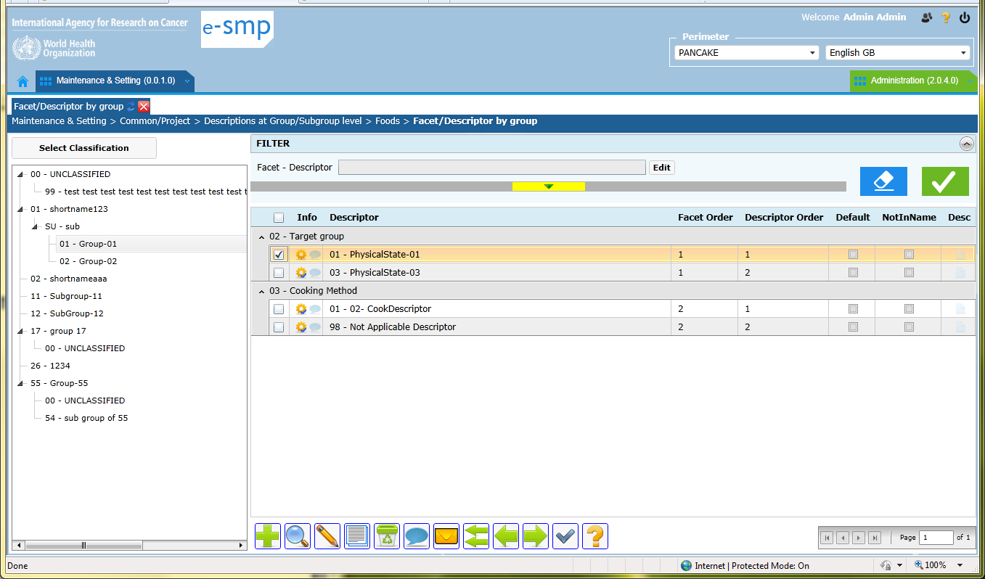

Current problems:
          - Classification on left:
- It is not possible to select more than 1 group/subgroup
- It is necessary to select a group or subgroup or sub-subgroup (we cannot select all or none)
          - Search “facet – descriptor”:
- It is done within the selected group/subgroup on left and never on all the groups/subgroups
          - Proposition:
- In the classification part, the groups/subgroups/sub-subgroups with facets attached need to be highlighted and the other levels can be in grey.
ITeal: --> OK
- The information group/subgroup needs to be added in the list because of multi-selection
ITeal: --> OK
- Possibility to select some groups/subgroups or all of them or none in the classification part (left)
ITeal: --> OK
- The filter on facet-descriptor needs to be applied on the selected groups/subgroups or on all (all if no group/subgroup selected OR if all groups/subgroups selected)
ITeal: As discussed in Skype on 27/06:
The facet descriptors is based on selected classification on the left
IARC: can you confirm that this approach is correct; “if nothing is selected in the classification (in left part), the search will be done on the facets/descriptors search fields whatever the classification”?

- The filter has to be done on facet level (whatever the descriptors) by adding a checkbox at facet level in the following pop-up
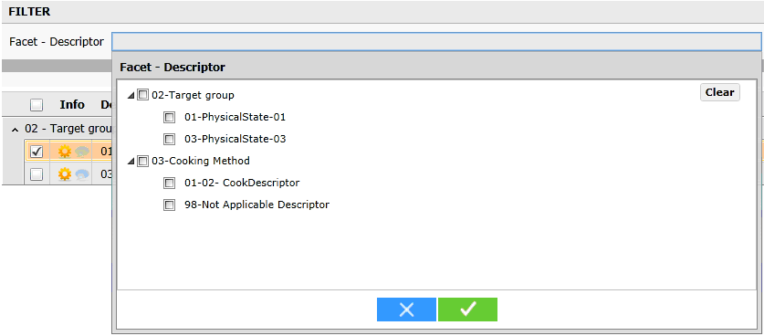
ITeal: As discussed in Skype on 27/06:
- It's possible to filter on Facet (s) only
- Check facet + 1 or several descriptors: --> search group with facet + descriptor
- Check facet + no descriptor --> search group with facet (don't care on descriptor)

--> This behavior will be applied for all facetstring filter

IARC: for the moment, it is not possible to select only facet, see below. Can you confirm that it will be possible?
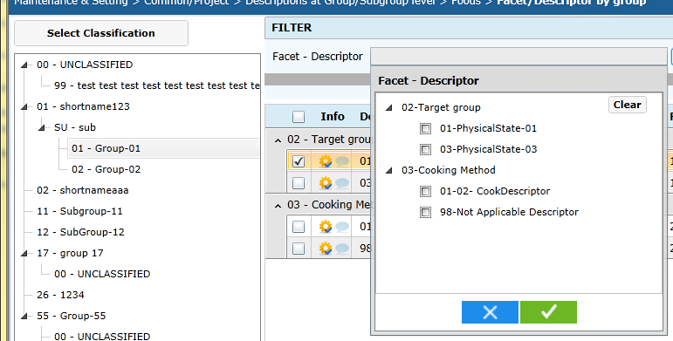

→ This proposition can be applied to all food screens (from food list to food controls)

Liste proposition:

Group or subgroup or sub-subgroup code and name as selected (*)

Facet code and name
Descriptor code & descriptor Name (2 columns) & Default & Not in the Name & Order (**)

(*) if subgroup then group not displayed here in the list
(**) the facet order is not needed in this screen (cannot be changed). The sort on descriptor should not change the facet order (facets should always be sorted according to facet order whatever the sort done)

Example: Classification as new line. Can also be as a column in some screens (to be checked).

01 Potato
10 Production Method
02 Homemade D 1
01 Commercial 2
00 Undefined N 3

ITeal: As discussed in Skype on 27/06:
With the multi selection in the tree, the grid will be displayed with group (1 level or several levels) as in bellow figure:
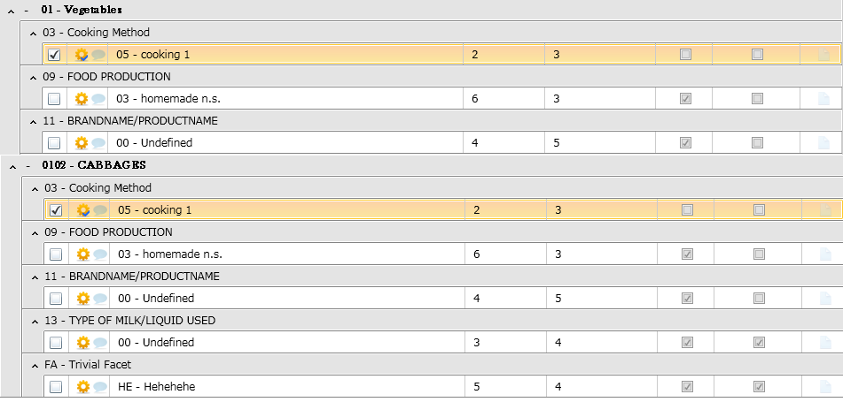

FICHE APROACH: (e.g. with FADE BY GROUP)

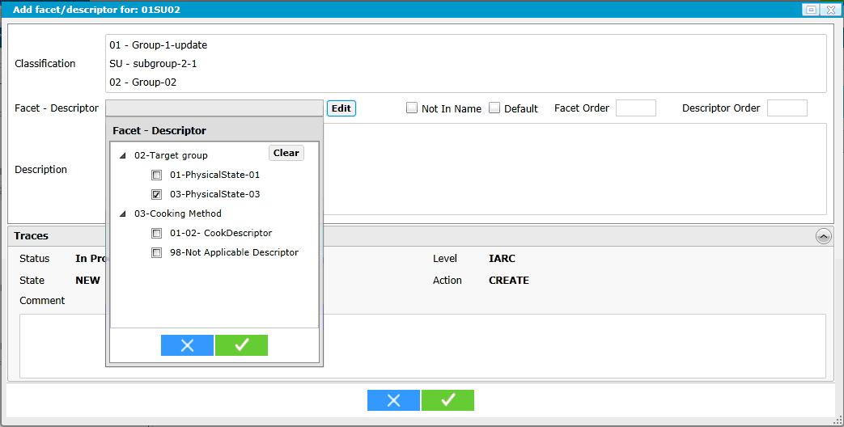
          - Add (green cross) and Edit (pen button):
- We open the facets/descriptors pop-up with all descriptors and we can only select one. Regarding the number of descriptors selected per group/subgroup in this table (e.g. can be more than 100 descriptors for 1 subgroup), it will take to much time for the user, to select the needed descriptors following this approach.
- We would like to update several records in the same time to save time for users.

- Proposition:
          - Using Edit button, several records can be selected
          - Using Add button the displayed fiche allows to add several descriptors in the same time using the fiche edit button
          - Adding the possibility to attribute the same status and/or comment to all the selected descriptors or only to one
→ This proposition can be applied to several food screens (from food description to food controls)

Example of Fiche:

Edit button at the top of the fiche: “Facet-Descriptor” pop-up
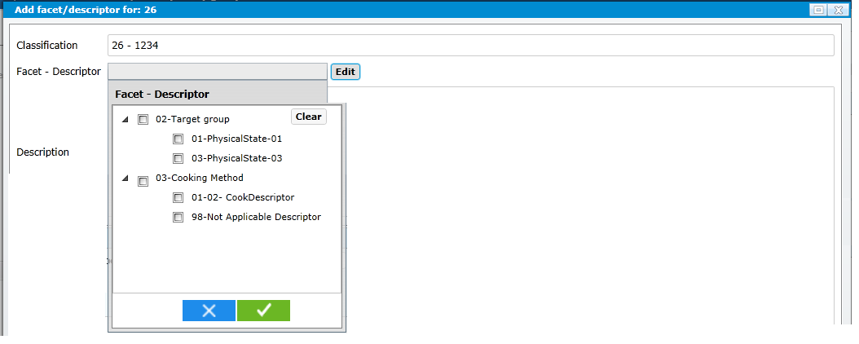

Complete fiche

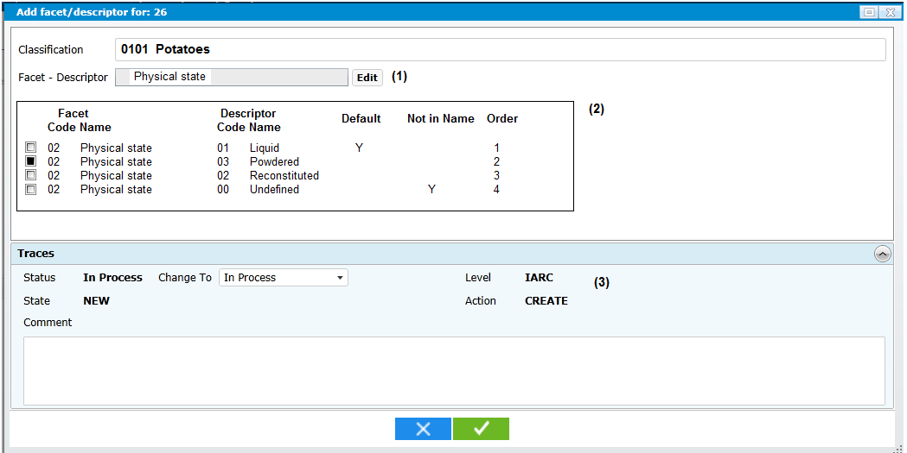
- If 1 facet is selected then facet name is displayed
- The fields Default, Not in Name and Order can be updated directly in the grid
- The displayed trace field values are the one where the cursor is focused on. If several lines are selected, only status and comment can be viewed and updatable.

ITeal: As discussed in Skype on 28/06: Fiche modification

- Common modification
with multiple selection in the tree, when we click on add button: we'll have to select classification in the fiche screen (it's read-only currently):
- if 1 selection on the left --> same with current
- if multi selection of the left, we can display the list to select in fiche within the items selected in tree
and select the first by default
IARC: OK classification field can be updatable. The default classification can be the one where the cursor is before the “Add”. What do you think?

- Specific modification
- FadebyGroup

- In the fiche screen (add new), we can select multiple facets/ descriptors; the information for them will be modified directly in the grid. Description & Trace will be modifiedy for each selected item of this grid.
- When select single record and click Edit or double click on 1 records --> the behavior is the same with current version
IARC: not clear, where is the Edit button? If double click on 1 record then another fiche is displayed??… Not clear
- Select multiple records --> Click edit –> mass update

When click on save button --> save all modifications:
- if 1 item has error --> others will be save normally
- if all items are saved successfully --> close dialog & refresh the list screen
- if at least 1 error occurs --> the fiche is not closed

The errors will be displayed as 1 error column like in mass translation
IARC: for the moment, the mass translation is not working in MSapp. Can you specify what is this column?

- Food screen like standard unit (with add button)
- List screen: modified like fadebygroup
- Classification Fiche screen: same with fadebygroup
- Fiche: Create grid to edit multiple items like fadebygroup
- Select multiple records --> Click edit –> mass update

- Food screen like Rawcooked (no add button)
- List: same with fadebygroup
- FIche: Is already the same with standard Unit --> no modification needed
- Select multiple records --> Click edit –> mass update

- Food Screen like "Fat Left Over the dish" (no tree)
- Select multiple records --> Click edit –> mass update

